Quality, Service Improvement and Redesign Virtual (QSIRV)
The Quality, Service Improvement and Redesign (QSIR) programmes are the latest iteration of a highly successful service improvement programme that has been delivered over many years to hundreds of staff involved in healthcare.
Delivered in a variety of formats to suit different levels of improvement experience, the QSIR programmes are supported by publications that guide participants in the use of tried and tested improvement tools and featured approaches and encourage reflective learning.
The QSIR programmes suit clinical and non-clinical staff involved in service improvement within their organisation and/or system. Each cohort typically consists of people from a range of backgrounds and professions. We believe this mix helps to make the programmes so vibrant. There’s always huge wisdom in the room and many perspectives, providing a rich learning environment
CPFT are currently delivering QSIR Virtual which will be delivered online by members of the Trusts Improvement and Programme Delivery Team.
The course consists of 8 modules delivered across 4 sessions lasting 2 hours each with access to Virtual Action Learning Sets and drop in Café sessions where you can ask any queries. During the course, you will study the following topics:
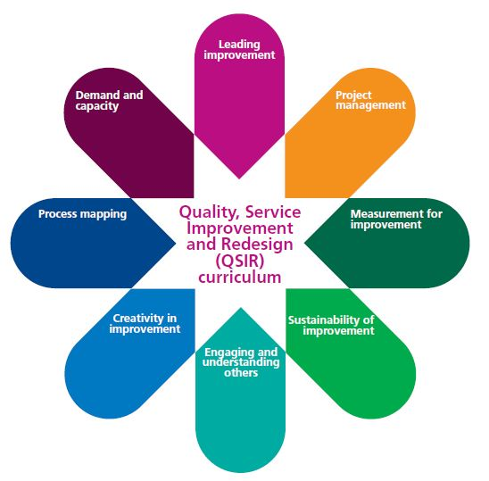
The QSIR programme is open to all staff across the Trust, regardless of role or banding but you should have your line managers support and be able to implement a project using QSIR.
The dates for May, June and July 2022 are available. If you are unable to attend all the sessions in one cohort you can attend another as the course is modular however you must complete all modules.
You can apply to the course by clicking Apply. You will need to complete a brief application form which will be reviewed and your place confirmed. Zoom/Teams Links will be sent nearer to the course date.
If you have any queries, please don’t hesitate to contact us via qualityimprovement@cpft.nhs.uk

Cohort V5 | M1 | M2 | M3 | M4 | M5 | M6 | M7 | M8
Cohort/Module | Introduction to Quality improvement | Model for improvement & Project Management | Introduction to Measurement for Improvement | Sustainability of Improvement | Engaging stakeholders, managing change and transitions | Creativity in Improvement | Process Mapping | Introduction to Demand and Capacity Management
Webinar Dates | 05/05/2022 |  | 12/05/2022 |  | 19/05/2022 |  | 26/05/2022
Webinar Times | 10 to 12 |  | 10 to 12 |  | 10 to 12 |  | 10 to 12
Cohort V6 | M1 | M2 | M3 | M4 | M5 | M6 | M7 | M8
Cohort/Module | Introduction to Quality improvement | Model for improvement & Project Management | Introduction to Measurement for Improvement | Sustainability of Improvement | Engaging stakeholders, managing change and transitions | Creativity in Improvement | Process Mapping | Introduction to Demand and Capacity Management
Webinar Dates | 06/06/2022 |  | 13/06/2022 |  | 20/06/2022 |  | 27/06/2022
Webinar Times | 10 to 12 |  | 10 to 12 |  | 10 to 12 |  | 10 to 12
Cohort V7 | M1 | M2 | M3 | M4 | M5 | M6 |  | M8
Cohort/Module | Introduction to Quality improvement | Model for improvement & Project Management | Introduction to Measurement for Improvement | Sustainability of Improvement | Engaging stakeholders, managing change and transitions | Creativity in Improvement | Process Mapping | Introduction to Demand and Capacity Management
Webinar Dates | 05/07/2022 |  | 12/07/2022 |  | 19/07/2022 |  | 26/07/2022
Webinar Times | 10 to 12 |  | 10 to 12 |  | 10 to 12 |  | 10 to 12

